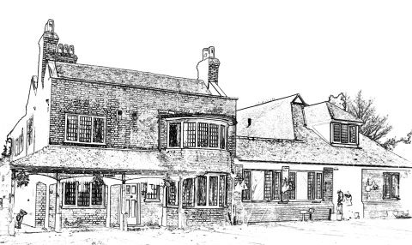
The Tile House Surgery

System Online Registration 12 – 15yrs

To enable you to have access to a childs online SystmOne account allowing you to request repeat prescriptions and book appointments and view medical records we require you to complete this form and provide the childs birth certificate.

Details of Person filling in the form
What relationship do you have to this child  (e.g. Parent, Step Parent, Guardian, Foster Carer): | First Name:  Surname:  Address:
Child’s Details
First Name: | Surname:
Date of Birth: | Sex: Male / Female
Address:  Post Code : | Home Tel.:  Mobile No:
Family Details
Mothers full name:  DOB: | Fathers full name:  DOB:

Who has Parental Responsibility?

Signature: _______________________________ Date: ________________________

Print: _______________________________

For Office use

Has the identity been checked?  Tick:  Birth Certificate | Yes No  Yes No
Has Parental Responsibility been established?  Tick which one:  Birth certificate  Letter from Solicitor | Yes No  Yes No  Yes No
Please state who has parental responsibility:
Ensure this is recorded in SystmOne

State the name of the person being given the proxy access

Online Registration 12 -15 years has been set up  Read code (consent – Xabui) - Note who has been given the access | Yes No  Yes No
Who checked the form?

Date:

NB – If the child is Gillick competent and wants their own access to Online then they will need to fill out the adult online form

